SubTask 2.1: Functionality Testing

To: kiranjain@gmail.com, misaonakano@gmail.com
Subject: Functionality Testing

Dear Kiran and Misao,
I am writing this email to show you my process of decrypting SESSID||C using the provided group session key (gsk). My method of decrypting involves the usage of the same OpenSSL cryptographic tool as you have.

SESSID||C is a concatenation of the Session ID and the ciphertext as seen in the diagram below.
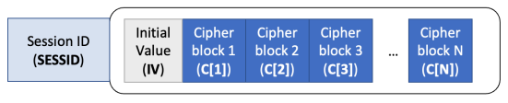
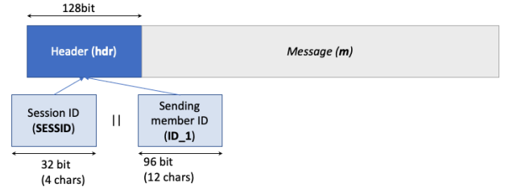

As the session ID contains 32 bits, or 4 bytes, as 8 bits equals to 1 byte, the Session ID can be extracted using the command below.
This command extracts the first 4 bytes of the entire message to obtain the Session ID.
Output:

After obtaining the session ID, the rest of the message can be obtained using the command below.
This command selects every byte from the end of the file up to the 5th byte. This contains the IV and the cipher text.
Output:

Next, knowing that the IV is the first 128 bits of the new IVCipher text file. The IV can be obtained using the command below.
This command extracts the first 16 bytes of the file to obtain the IV.
Output:

Knowing that the IV take up 16 bytes of IVCipher, the rest of the cipher text is obtained with the command below.
The command selects every byte from the end of IVCipher up to the 17th byte, which contains only the message.
Output:

With the IV and the message obtained, the message can now be decrypted. However, the IV will first need to be converted to a Hexadecimal format as the OpenSSL cryptographic tool takes in HEX values. Therefore, the IV is converted into a Hexadecimal format with the help of the command below.
Output:

By using the OpenSSL command, the provided gsk and the obtained IV in HEX, the message is decrypted.
This command utilizes AES-256-CTR.
Output:

Decrypted Values
Session ID: SES2
Sender ID: FIT2093User2
Message: My husband loves cats a lot. He has two kitties whose names are Emma and Wendy. They hate eating fish, instead, they love dry food.

Block diagram of the decryption method:
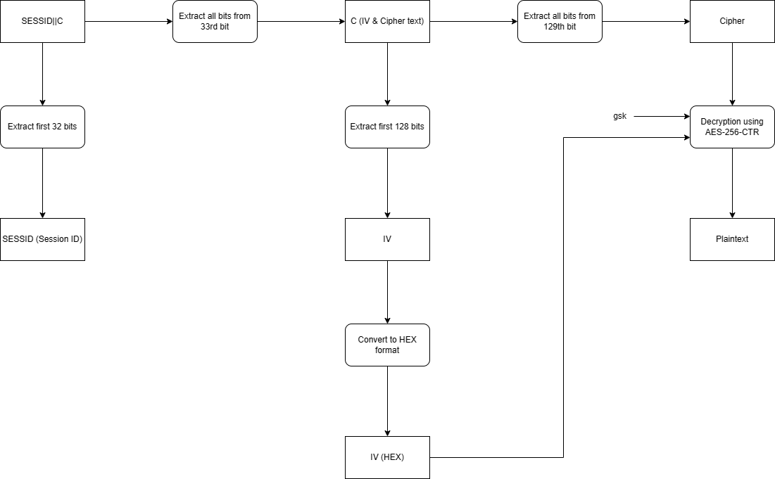

I hope you find this email helpful in understanding my decryption process.
Regards,
Braden

SubTask 2.2: Security Evaluation: Confidentiality

To: kiranjain@gmail.com, misaonakano@gmail.com
Subject: Security Evaluation: Confidentiality

Dear Kiran and Misao,
I am writing this email to inform you about the confidentiality security findings from my analysis of the group encryption method.

Security Considerations for CTR Mode of Operation
The block cipher mode of operation that you have used, CTR (Counter Mode), converts a block cipher into a stream cipher. Whenever a counter-initiated value is encrypted, it is then XORed with plaintext, producing the ciphertext block. This mode of operation along with a strong block cipher such as AES-256, provides confidentiality as each plaintext block is encrypted independently. Confidentiality can be achieved by preventing attacks such as Ciphertext-Only Attacks.

Security Vulnerability
Upon further inspection, I found a significant vulnerability in how the IV is generated. The IV is derived from the time of day which might lead to repeating IVs. I will explain how this vulnerability can cause issues.

Using the same method in the prior email, the IV and Ciphertext are obtained with the tail command, followed by the head command to obtain the IV before finally converting the IV to hexadecimal format. These steps are repeated for every message.

These are the results:
As you can see, IVs 0-2 are the exact same. This would cause these messages to produce the same ciphertext block when encrypted, eliminating the randomness of the encryptions while simultaneously enabling attackers to exploit this by analysing the patterns and infer information.

Exploitation by Attacker Zoe
Zoe, an attacker, who eavesdropped on the encrypted group messages, found out about the ID “DeltaZhang00” who sent the third message by overhearing “DeltaZhang00”s private conversation.

By knowing this ID, Zoe could target the messages sent by this user and analysis the patterns of the intercepted ciphertexts. Through this, Zoe could manipulate the messages sent by this specific user or even recover the gsk to decrypt every message, compromising the confidentiality of this conversation.

Recommendations
Here are a few recommendations to fix this vulnerability.
- Use unique IVs: By using a unique IV for each encryption operation, it would be difficult for an attacker to analyse patterns and compromise the conversation. Unique IVs can be generated with a basic random number generator.
- Keep track of IVs: By keeping track of what IVs have been used, we can prevent the occurrence of repeating IVs. This makes it difficult for an attacker to target messages containing the same IVs and obtaining private information.
- Key rotation: Periodically rotating the encryption keys ensures that even if a previous key is compromised, future messages are encrypted with a different key.

I hope you find this email helpful in understanding the potential vulnerabilities of the group encryption method.

Regards,
Braden

SubTask 2.3: Security Evaluation: Integrity/Authenticity

To: kiranjain@gmail.com, misaonakano@gmail.com
Subject: Security Evaluation: Integrity/Authenticity

Dear Kirao and Misao,
I am writing this email to describe the modifications I have made to the group encryption method. I have decided to incorporate a digital signature to the messages to prevent group insider integrity attacks.

Digital Signature
First, using GPG, a key-pair is generated.
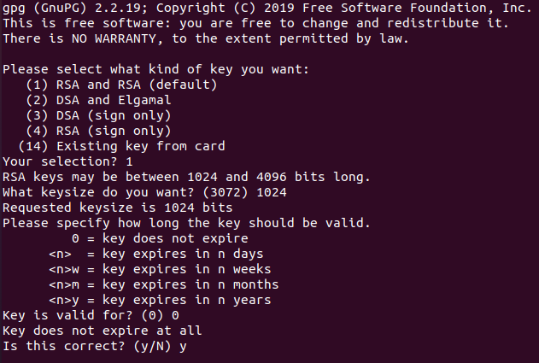
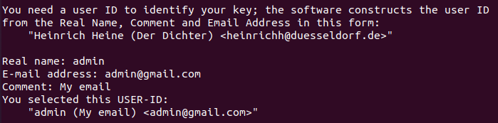
Type of Key: RSA and RSA
Key Length: 1024 bits
Expiration date: Never
Real Name: admin
Email Address: admin@gmail.com
Comment: My email

After the key is created, the user would enter a password only they know to protect their new key. This ensures that only the user has access to their secret key.
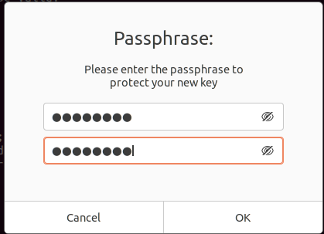
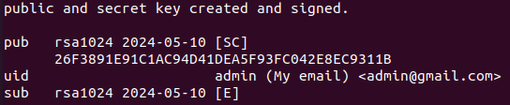
The public and secret key are now created.

Next, the ciphertext sent by “DeltaZhang00” is signed using the command below.
Output:
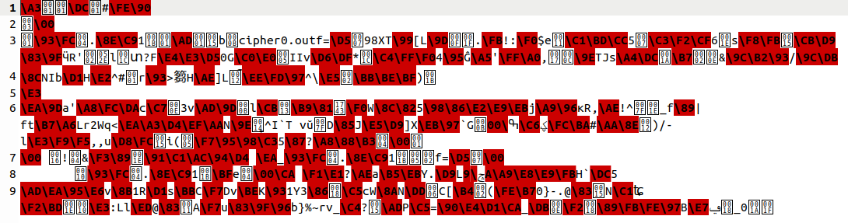
A quick verification is performed to check if the signature is good using the command below.
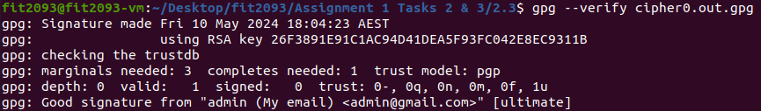
Status: Good signature

The message (cipher0.txt) is then retrieved with the command below.
Output:
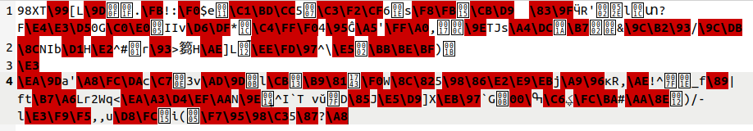

After that, a detached signature is generated using the command below.
The detached signature is also verified using the command below.
Status: Good signature

As you can observe, both the signature and detached signature produce a “Good signature” outcome when verified if the ciphertext has not been tampered with. I will explain what will happen if an attacker intercepts a message below.

Inside attack
In the case of an attack such as “BobHowes0000” intercepting a message sent by “DeltaZhang00”, this will be the result.

“BobHowes0000” has modified cipher0.txt originally sent by “DeltaZhang00”, as seen below.
Original by “DeltaZhang00”:
Intercepted by “BobHowes0000”:
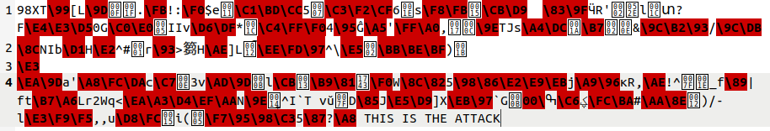

Using the verification command, it can be observed that the message has been compromised and is no longer authentic.
Status: Bad Signature

With this signature, when other members decrypt the message intercepted by “BobHowes0000”, they can recognize that the message has been manipulated and is not the original message sent by “DeltaZhang00”. This maintains the integrity and authenticity of the group encryption method by ensuring that malicious group insiders such as “BobHowes0000” cannot fool other members into thinking that he is honest member “DeltaZhang00”.

Block diagram of the encryption method:
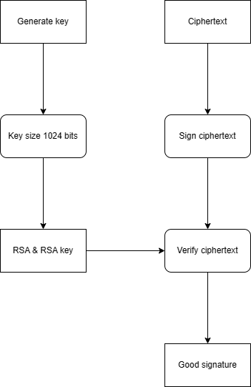

I hope you find this email helpful in understanding how the modified group encryption method works.

Regards,
Braden

